Minutes

Wednesday, 31 July 2024



**Acknowledgement of Country**

We wish to acknowledge the traditional custodians of the land we are meeting on, the Wadandi people. We wish to acknowledge and respect their continuing connection to the land, waters and community.

We pay our respects to all members of the Aboriginal communities and their culture; and to Elders past and present, their descendants who are with us today, and those who will follow in their footsteps.

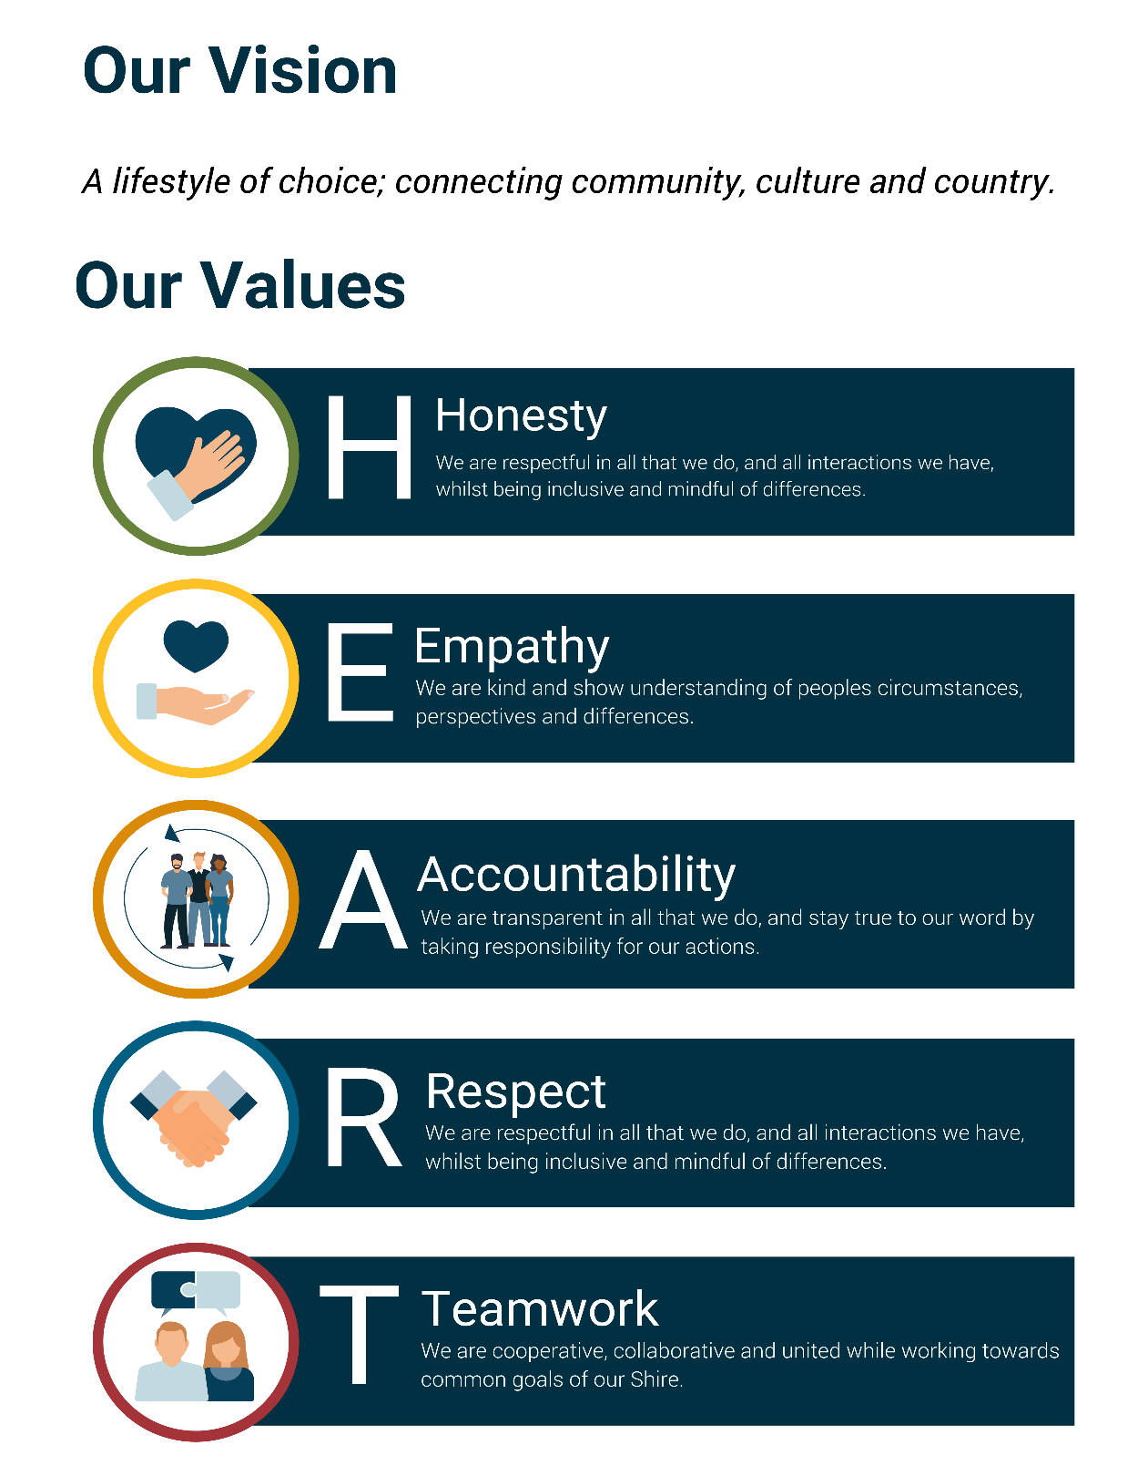

**TABLE OF CONTENTS**

1. Declaration of Opening/Announcement of Visitors 4

2. Record of Attendance/Apologies/Leave of Absence (Previously Approved) 4

3. Declarations of Interest 4

4. Confirmation of Minutes 5

4.1. Climate Change Adaptation and Sustainability Committee Minutes - 24 February 2024 5

5. Presentations 5

6. Reports 6

6.1. Capel Coastal Sub-Committee Local Representative Appointments 6

7. Meeting Closure 11

**1. Declaration of Opening/Announcement of Visitors**

Acknowledgement of Country

*‘We wish to acknowledge the traditional custodians of the land we are meeting on, the Wadandi people. We wish to acknowledge and respect their continuing connection to the land, waters and community. We pay our respects to all members of the Aboriginal communities and their culture; and to Elders past and present, their descendants who are with us today, and those who will follow in their footsteps.’*

**2. Record of Attendance/Apologies/Leave of Absence (Previously Approved)**

|  |  |  |
| --- | --- | --- |
| PRESENT: | |  |
|  | Councillor – Deputy Chair | J Fergusson |
|  | Councillor | P McCleery |
|  | Councillor | R Mogg |
|  |  |  |
|  | Chief Executive Officer | G MacMile |
|  | A/Director Infrastructure and Development | S Chamberlain |
|  | Senior Sustainability Officer | G Salter |
|  | Governance Support Officer | B Facey |
|  |  |  |
|  |  |  |
| LEAVE OF ABSENCE: | | Nil |
|  |  |  |
| APOLOGY: | Councillor - Chair | S Schiano |
|  |  |  |
| ABSENT: | Councillor | T Sharp |
|  |  |  |

**3. Declarations of Interest**

Nil

**4. Confirmation of Minutes**

4.1. Climate Change Adaptation and Sustainability Committee Minutes - 24 February 2024

|  |  |
| --- | --- |
| **4.1.** | **Climate Change Adaptation and Sustainability Committee Minutes - 28 February 2024** |

**Voting Requirements**

Simple Majority

|  |
| --- |
| **OC/2024/04 - Officer's Recommendation / Council Decision- 4.1**  *Moved Cr McCleery, Seconded Cr Mogg.*  **That the Minutes of the Climate Change Adaptation and Sustainability Committee Minutes – 28 February 2024 be confirmed as a true and correct record.**  **Carried 3 / 0**  *For - Cr Fergusson, Cr McCleery and Cr Mogg*  *Against - Nil* |

**5. Presentations**

**5.1 Introducing Greg Salter, Senior Sustainability Officer – Gordon MacMile**

**5.2 Peron Naturaliste Partnership (Future Initiatives) Discussion – Gordon MacMile**

**5.3 Project Arum Lily (4 Local Governments) Update – Gordon MacMile**

**6. Reports**

6.1. Capel Coastal Sub-Committee Local Representative Appointments

|  |  |
| --- | --- |
| **6.1.** | **Capel Coastal Sub-Committee Local Representative Appointments** |

|  |  |
| --- | --- |
| **Author** | Strategic Governance and Risk Coordinator, Tahlia Shipley |
| **Authorising Officer** | Chief Executive Officer, Gordon MacMile |
| **Nature of the Decision** | Executive/Strategic |
| **Attachments** | 1. CONFIDENTIAL - EOI Capel Coastal Sub Committee Form - Application 1 [**6.1.1** - 2 pages] 2. CONFIDENTIAL - EOI Capel Coastal Sub Committee Form - Application 2 [**6.1.2** - 2 pages] 3. CONFIDENTIAL - EOI Capel Coastal Sub Committee Form - Application 3 [**6.1.3** - 2 pages] 4. Capel Coast Sub Committee To R [**6.1.4** - 5 pages] |
| **Confidential Status** | *This item is not a confidential matter.* |

**Proposal**

Appoint the Shire of Capel Coastal Sub Committee (the sub-committee) Community Representatives.

**Officer’s Recommendation**

That the Climate Change, Adaptation and Sustainability Committee:

1. Appoint the three Community Representatives included within attachments 5.1.1, 5.1.2 and 5.1.3.
2. Request the Council to support the appointments of the community representatives.

**Background**

The Sub Committee was identified to support the governance and consideration of initiatives in relation to coastal matters. Council recognises that the implementation of the CHRMAP along with the ongoing management of the Capel Coast with the community, requires a long-term commitment that is consistent and sustainable.

Following the adoption of the sub-committees Terms of Reference, an expression of interest was advertised through the Shire’s website, social media and notice boards for applications for representatives of the community.

The expression of interest was advertised on 27 May 2024 and closed on Friday 5 July 2024. During the submission period a total of 3 applications were received.

Previous Council Decisions

31 January 2024 Ordinary Meeting of Council - (OC/2024/12) Council resolved the following:

‘That Council,

1. Endorses the Final Capel Coastal Hazard Risk Management and Adaptation Plan (CHRMAP) (Attachments 14.5.1 to 14.5.12) as a guide for future planning and coastal management in the Shire.

1. Notes all the comments made by members of the community throughout the process of the production of the Capel CHRMAP as detailed in Attachments 14.5.4, 14.5.11, 14.5.12, 14.5.14 and 14.5.15;

1. Accepts the Recommendations for Management Units MU1-Peppermint Grove Beach, MU2- Capel Coast and MU3-Dalyellup as set out in Section 8.7 of the Final Shire of Capel CHRMAP and summarized in Attachment 14.5.16

1. Does not accept the funding mechanisms detailed in the Benefit Distribution Analysis in Attachments 14.5.8 and 14.5.9 for Management Units 1 and 2 to construct a levee on the Capel River (PR6) and for Management Unit 3 to construct groynes in Dalyellup and resolves to investigate alternative funding mechanisms for the actions identified in the Final Capel CHRMAP.

1. Refers the Final Capel CHRMAP to the Department of Planning, Lands and Heritage and the Western Australian Planning Commission for their consideration and recommends that a two-stage approach to CHRMAP production is considered, in order to allow for better community understanding and engagement.

1. Resolves to set up a Capel Coast Sub-Committee to the Climate Change and Sustainability Committee with responsibility for the assistance in the implementation of the Final Capel CHRMAP and to include elected members, Shire Officers, community representatives and other appropriate organisations agencies.

1. Resolves to continually update the Final Capel CHRMAP as necessary as new data or information becomes available.’

27 March 2024 Ordinary Meeting of Council - (OC/2024/47) Council endorsed the following:

‘That Council adopt the draft Capel Coast Sub Committee Terms of Reference as per Attachment 13.2.1, and support the Climate Change, Adaptation and Sustainability Committee to oversee the actions, activities and recommendations made by the Sub Committee.’

**Decision Framework**

**Shire of Capel Strategic Community Plan 2023-2033**

Direction 2 - Manage and protect our environment

2.1 Improved management of our natural environment assets and attractions

2.2 Increased community capacity in supporting positive environmental management

2.3 A Shire committed to sustainable practices

2.5 Improved connection and access to natural assets of the forest and coastal environment

2.7 Urban planning that supports sustainable development

Direction 4 - Deliver good leadership, governance and decision-making

4.2 Informed and transparent decision making

4.3 Contemporary planning and local development

Direction 5 - Provide and maintain suitable infrastructure and facilities

5.4 Improved beach infrastructure to support a healthy beach lifestyle

**Corporate Business Plan 2023-2027**

DEVS 4 -**CHRMAP** - Prepare and implement a joint Coastal Hazard Risk Mitigation Plan including community engagement and consultation.

**Statutory Framework**

**Local Framework**

There are no local frameworks relevant to this item.

**State Framework**

There are no state frameworks relevant to this item.

**Federal Framework**

There are no federal frameworks relevant to this item.

**Policy Framework**

There are no Council policies relevant to this item.

**Implications**

**Risk Implications**

|  |  |  |  |
| --- | --- | --- | --- |
| **Risk** | **Likelihood** | **Consequence** | **Mitigation** |
| **Risk 1**  Reputation  **Rating:** Medium | Possible | Moderate | Ensuring diverse representation to the sub-committee by appointing the community representation. |
| **Risk Description:** Failure to consider community representation on the sub-committee. | | | |
| **Opportunity**: The future advocation and considerations of the Sub Committee for the impacts and actions identified through the CHRMAP. | | | |

**Financial Implications**

Budget

There are no financial implications relevant to this proposal.

Long Term

There are no future long term financial implications relevant to this proposal.

**Sustainability Implications**

The Capel Coast Sub Committee will consider ongoing implications from a social, environmental, asset and economic perspective. These implications will be considered at the time of the reports relevant to the committee.

**Consultation/Engagement**

**External Consultation**

No external consultation was undertaken.

**Internal Consultation**

Consultation between the Strategic Governance and Risk Coordinator and Manager of Planning occurred following the close of submissions.

**Officer Comment**

The Capel Coast Sub Committee will consider the impacts of:

* temporary coastal flooding;
* permanent marine inundation;
* increased heat-related health issues;
* changes in mosquito activity; and
* subsequent impact on residents and economic impacts on those industries which rely on our waterways and coast, such as tourism and accommodation businesses and commercial fishing.

The Sub Committee will work to identify future solutions and investigations of these impacts on the Capel community.

A vital part of the future mitigation and management strategies will involve investigations to be undertaken on the financial impacts and provide recommendations on strategies and financial assistance opportunities.

The sub-committee consists of several community representatives to ensure proper engagement and involvement of the community, along with elected members, Shire Officers and representatives from other relevant organisations.

No submission was received for a Dalyellup coast representative. However, officers have recommended to appoint all three applications due to having diverse backgrounds that could provide community representation across the district. There are three community representative positions available, and the Climate Change, Adaptation and Sustainability Committee may choose to fill them with the submitted applications.

Alternatively, the Climate Change, Adaptation and Sustainability Committee may request for an Expression of Interest to remain advertised on the Shire’s website for a Dalyellup resident and choose to appoint two of the community submissions.

Following the appointments, officers will advise the community representatives of their appointment and prepare the commencement of the meetings.

**Summary**

The Climate Change, Adaptation and Sustainability Committee is asked to consider appointing community representatives for the Capel Coastal Sub-Committee.

Officers will provide reports to the Climate Change, Adaption and Sustainability Committee on the progress and initiatives formed within the sub-committee.

**Voting Requirements**

Simple Majority

|  |
| --- |
| **Officer’s Recommendation – 6.1.** |

|  |
| --- |
| **CC/2024/05 - Officer's Recommendation / Council Decision - 6.1**  *Moved Cr McCleery, Seconded Cr Mogg.*  **That the Climate Change, Adaptation and Sustainability Committee:**   1. **Appoint the three Community Representatives included within attachments 5.1.1, 5.1.2 and 5.1.3.** 2. **Request the Council to support the appointments of the community representatives.**   **Carried 3 / 0**  *For - Cr Fergusson, Cr McCleery and Cr Mogg*  *Against - Nil* |

**7. Meeting Closure**

*There being no further business, the Deputy Chair declared the meeting closed at 3.27pm.*